AWS UPLOAD

1. Get Bluetooth Mac Address
2. Log into AWS. Go to Service -> S3

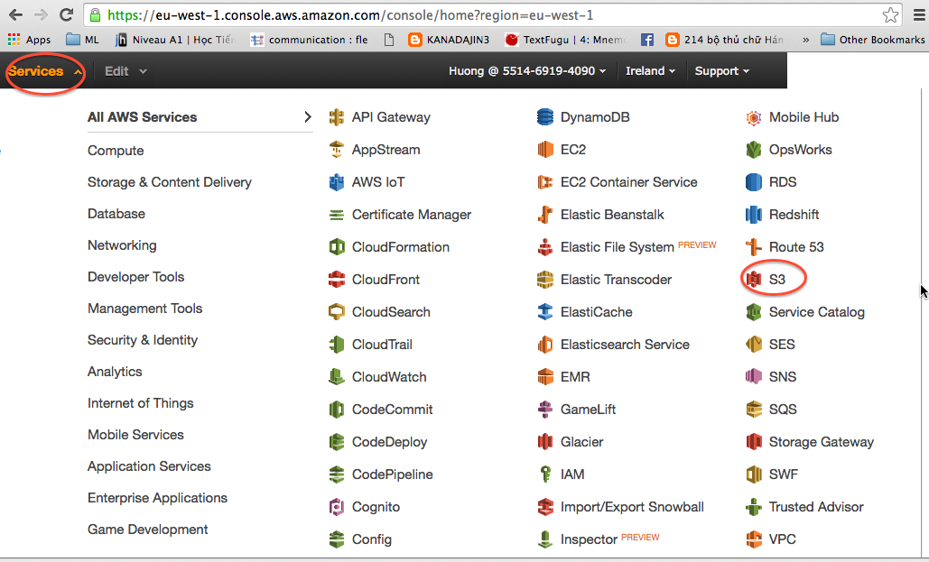

1. Add access for Bluetooth device
   1. Select **ex000** bucket

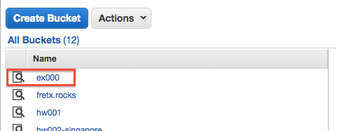

* 1. Select file **exercises.json**. Download to your local computer

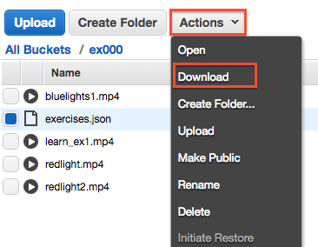

* 1. Open file with Notepad or similar text edit program (Excel should not be used).

Each exercise should be included within curly brackets {} as below.

{

ex1

}

Exercises should be separated by a comma.

{

ex1

},

{

ex2

}

Ex:

* The current file ends with exercise 4

{

"labels": [

"S6 F3",

"S5 F0",

"S5 F2",

"S6 F3",

"S5 F3",

"S4 F2",

"S4 F0",

"S5 F2",

"S6 F3",

"S5 F0",

"S5 F2",

"S4 F2",

"S5 F3",

"S5 F2",

"S5 F0"

],

"id": 4,

"title": "Redemption Song",

"video": null,

"nextId": -1

}

* To create exercise 5, copy the text for exercise 4, insert comma after exercise 4 and paste.

{

"labels": [

"S6 F3",

"S5 F0",

"S5 F2",

"S6 F3",

"S5 F3",

"S4 F2",

"S4 F0",

"S5 F2",

"S6 F3",

"S5 F0",

"S5 F2",

"S4 F2",

"S5 F3",

"S5 F2",

"S5 F0"

],

"id": 4,

"title": "Redemption Song",

"video": null,

"nextId": -1

},

{

"labels": [

"S6 F3",

"S5 F0",

"S5 F2",

"S6 F3",

"S5 F3",

"S4 F2",

"S4 F0",

"S5 F2",

"S6 F3",

"S5 F0",

"S5 F2",

"S4 F2",

"S5 F3",

"S5 F2",

"S5 F0"

],

"id": 4,

"title": "Redemption Song",

"video": null,

"nextId": -1

}

- Modify the **nextId** fields in **Ex 4**

{

"labels": [

"S6 F3",

"S5 F0",

"S5 F2",

"S6 F3",

"S5 F3",

"S4 F2",

"S4 F0",

"S5 F2",

"S6 F3",

"S5 F0",

"S5 F2",

"S4 F2",

"S5 F3",

"S5 F2",

"S5 F0"

],

"id": 4,

"title": "Redemption Song",

"video": null,

**"nextId": -1 -> Change to "nextId": 5**

},

{

"labels": [

"S6 F3",

"S5 F0",

"S5 F2",

"S6 F3",

"S5 F3",

"S4 F2",

"S4 F0",

"S5 F2",

"S6 F3",

"S5 F0",

"S5 F2",

"S4 F2",

"S5 F3",

"S5 F2",

"S5 F0"

],

"id": 4,

"title": "Redemption Song",

"video": null,

"nextId": -1

}

- Modify the **content of Ex 5**

**labels -> insert notes for the new exercise. Ex:**

{

**"labels": [**

**"S4 F0",**

**"S5 F2",**

**"S6 F3",**

**"S5 F0",**

**"S5 F2",**

**"S4 F2",**

**"S5 F3",**

**"S5 F2",**

**"S5 F0"**

**],**

"id": 4,

"title": "Redemption Song",

"video": null,

"nextId": -1

}

**id -> change id to 5**

{

"labels": [

"S4 F0",

"S5 F2",

"S6 F3",

"S5 F0",

"S5 F2",

"S4 F2",

"S5 F3",

"S5 F2",

"S5 F0"

],

**"id": 4, -> Change to “id”: 5**

"title": "Redemption Song",

"video": null,

"nextId": -1

}

**title -> change title to new exercise’s title**

{

"labels": [

"S4 F0",

"S5 F2",

"S6 F3",

"S5 F0",

"S5 F2",

"S4 F2",

"S5 F3",

"S5 F2",

"S5 F0"

],

"id": 4,

**"title": "Redemption Song", -> Change to “title”: “Hello song”**

"video": null,

"nextId": -1

}

**id -> change id to 5**

{

"labels": [

"S4 F0",

"S5 F2",

"S6 F3",

"S5 F0",

"S5 F2",

"S4 F2",

"S5 F3",

"S5 F2",

"S5 F0"

],

**"id": 4, -> Change to “id”: 5**

"title": "Redemption Song",

"video": null,

"nextId": -1

}

**video -> change video to new exercise’s video file name (keep video as null if there’s no video for the exercise)**

{

"labels": [

"S4 F0",

"S5 F2",

"S6 F3",

"S5 F0",

"S5 F2",

"S4 F2",

"S5 F3",

"S5 F2",

"S5 F0"

],

"id": 4,

"title": "Redemption Song",

**"video": null, -> Change to “video”: “newsong.mp4”**

"nextId": -1

}

**Note: *KEEP nextId AS -1 IF THIS IS THE LAST EXERCISE***

* 1. Save and Upload **exercises.json and new video file (newsong.mp4)** back to AWS S3, bucket **ex000**.

